

***Welcome to our church and to this service***

This pew-sheet gives details of the parts of the service that change week by week; it should be used with the Mass in Ordinary Time book

(page number shown in brackets).

***Everyone*** *is welcome to come forward at the giving of Communion, either to receive the Sacrament or a personal blessing.*

Gluten-free wafers and non-alcoholic wine are available on request. Please let the sidesperson know***.***

**Sunday August 25th 2024**

**22nd Sunday in Ordinary Time**

**The heart of the law**

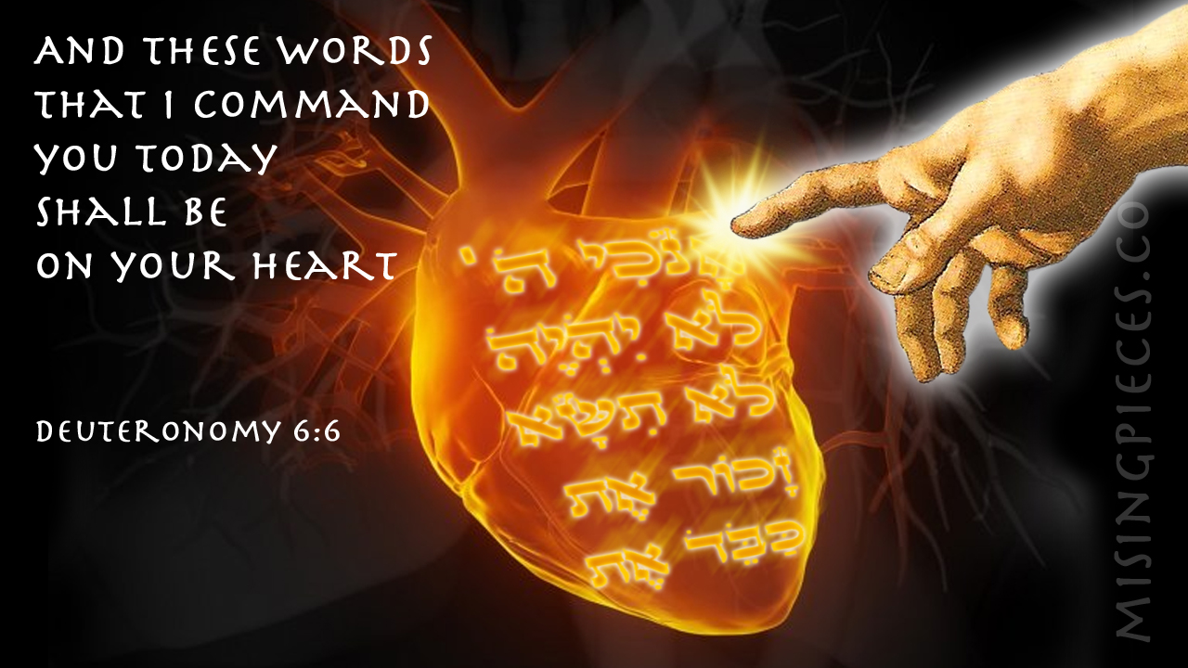

**Mass Setting**: *Missa Brevis* – James MacMillan (b.1959)

**Organ Music:**  *White note paraphrase  -* James MacMillan (b. 1959)

**Welcome and notices**

**Introit hymn: 342 Breathe on me breath of God**(t.452 Carlisle)

**Introit** *(p3*): Have mercy upon me, O Lord, for I have called daily upon thee: for thou, O Lord, art gracious and merciful, and plenteous in thy loving-kindness toward all them that call upon thee. ***Ps.*** Bow down thine ear, O Lord, and hear me: for I am poor and in misery. Glory be ………..

**Gloria** *(p4): setting by Martin Shaw*

**Collect** *(p8****):*** Lord of all power and might, who art the author and giver of all good things: graft in our hearts the love of thy name, increase in us true religion, nourish us with all goodness, and of thy great mercy keep us in the same; through Jesus Christ thy Son our Lord, who liveth and reigneth with thee, in the unity of the Holy Spirit, one God, now and for ever.

**AMEN**.

**Old Testament Reading:**  Deuteronomy 4: 1-2; 6-9

So now, Israel, give heed to the statutes and ordinances that I am teaching you to observe, so that you may live to enter and occupy the land that the Lord, the God of your ancestors, is giving you. You must neither add anything to what I command you nor take away anything from it but keep the commandments of the Lord your God with which I am charging you. You must observe them diligently, for this will show your wisdom and discernment to the peoples, who, when they hear all these statutes, will say, ‘Surely this great nation is a wise and discerning people!’ For what other great nation has a god so near to it as the Lord our God is whenever we call to him? And what other great nation has statutes and ordinances as just as this entire law that I am setting before you today?

But take care and watch yourselves closely, so as neither to forget the things that your eyes have seen nor to let them slip from your mind all the days of your life; make them known to your children and your children’s children.

**Epistle**: James 1: 17-27

Every generous act of giving, with every perfect gift, is from above, coming down from the Father of lights, with whom there is no variation or shadow due to change. In fulfilment of his own purpose, he gave us birth by the word of truth, so that we would become a kind of first fruits of his creatures.

You must understand this, my beloved: let everyone be quick to listen, slow to speak, slow to anger; for your anger does not produce God’s righteousness. Therefore, rid yourselves of all sordidness and rank growth of wickedness, and welcome with meekness the implanted word that has the power to save your souls. But be doers of the word, and not merely hearers who deceive themselves. For if any are hearers of the word and not doers, they are like those who look at themselves in a mirror; for they look at themselves and, on going away, immediately forget what they were like. But those who look into the perfect law, the law of liberty, and persevere, being not hearers who forget but doers who act—they will be blessed in their doing. If any think they are religious, and do not bridle their tongues but deceive their hearts, their religion is worthless. Religion that is pure and undefiled before God, the Father, is this: to care for orphans and widows in their distress, and to keep oneself unstained by the world.

**Gradual & Alleluia:** The heathen shall fear thy Name, O Lord: and all the kings of the earth thy majesty. When the Lord shall build up Zion: and when his glory shall appear.

(Cantor) Alleluia, alleluia, alleluia.

**(All) Alleluia, alleluia, alleluia.**

**O sing unto the / Lord a . new / song:**

**for he hath done / marvel.lous / things.**

**Alleluia, alleluia, alleluia**

**Gospel:** Mark 7: 1-8, 14-15, 21-23

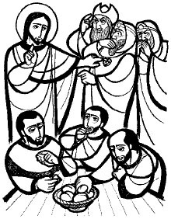**N**ow when the Pharisees and some of the scribes who had come from Jerusalem gathered around him, they noticed that some of his disciples were eating with defiled hands, that is, without washing them. (For the Pharisees, and all the Jews, do not eat unless they thoroughly wash their hands, thus observing the tradition of the elders; and they do not eat anything from the market unless they wash it; and there are also many other traditions that they observe, the washing of cups, pots, and bronze kettles.) So the Pharisees and the scribes asked him, “Why do your disciples not live according to the tradition of the elders, but eat with defiled hands?” He said to them, “Isaiah prophesied rightly about you hypocrites, as it is written,

‘This people honours me with their lips,  
but their hearts are far from me;  
in vain do they worship me,  
teaching human precepts as doctrines.’

You abandon the commandment of God and hold to human tradition.”

Then he called the crowd again and said to them, “Listen to me, all of you, and understand: there is nothing outside a person that by going in can defile, but the things that come out are what defile.” For it is from within, from the human heart, that evil intentions come: fornication, theft, murder, adultery, avarice, wickedness, deceit, licentiousness, envy, slander, pride, folly. All these evil things come from within, and they defile a person.”

**Sermon**: preacher Fr Bill Robertson

**Intercessions** *(p14):*

**Sick, housebound and those in need**: Andy Bayliss, Martin Boland, Philip Bradfield, Peter Dickins, Christine Dunbar, Betty Duncan, Mary Findlay, David Glews, Morag Graham Brown, Sarah Gundry, Di McAdam, Euan Morley, Suzanna Ovenstone, Angelica Paterson, Isobel Poole, Jean Simpson and Susan Virtue.

**Year’s mind:**  William Reginald Charles, Nora Hastie, Brendan Thomas, David Henderson, Jane Roxburgh, Mary Georgina Dixon, Fulque Agnew, Rebecca Gladstone, Charles Reid, James Hooper, Dorothy Hogg-Lewis, Mary McDougall, Maria Cuadras and Thomas Adamson.

***Please stand for* The Peace**(*p.15*)

***The Peace*** *may be exchanged in the traditional way, but please be sensitive towards those who do not wish to do so.*

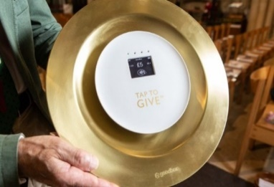**The Offertory:** *If you wish to make a cash donation, please place it in an envelope (to be found in the front of the hymn book) and it will be collected during the hymn. Contactless donations may be made by using our giving plate at the back of the church. Standing order is the preferred method of regular giving.*

*Please consider Gift Aid for your donations.*

**Offertory**: Look down, O Lord, to help me; let them be ashamed, and confounded together, that seek after my soul to destroy it: look down, O Lord, to help me.

**Offertory hymns: 341 Blest are the pure**  **353 Dear Lord and Father of mankind**

**The Prayer of Consecration** *(p.18)*

**The Invitation and Communion** *(p.26)*

**Communion Sentence:** O Lord, I will make mention of thy righteousness only, thou, God, hast taught me from my youth up until now: forsake me not, O God, in my old age, when I am grey headed.

**Everyone** is welcome to come forward at the giving of Communion, either to receive the Sacrament or a personal blessing.

**The Distribution**

**Communion Anthem:** Child of Hope – John Casken (b.1954)

**Communion hymn:** **318 My God accept my heart this day**

**Post-communion collect** (*p.28*)**:** Almighty God, thou dost renew us at thy table with the bread of life: may this holy food strengthen us in love and help us to serve thee in each other, this we ask in the name of thy Son, Jesus Christ our Lord. **Amen.**

**The Blessing**

**Angelus** (*p.29*)

**Recessional hymn:** **339 Be thou my vision**

**Organ Music:**  *Trumpet Tune -*Andrew Carter (b.1939)

***Please join us after the service for refreshments at the back of the church***

**Notices for the coming week August 25th**

*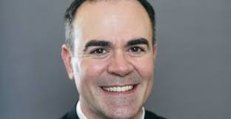Nearer and nearer draws the time*

*The time that will surely be*

*When the church will be filled with the people of God -*

*Fr Oliver’s institution it will be:*

**Wednesday 4 September 2024 at 7.00pm here in St Michael and All Saints Church**

**The Wednesday morning mass on Wed 4th Sept has been cancelled to allow for preparations and rehearsals.**

With the institution of Fr Oliver, we will be saying **goodbye to Fr Paul** who has been our interim pastor for the last year and a half. His last mass in this role will be on **Sunday Sept 1st**. Please join us for wine and nibbles as we thank him for all his work and support in his time with us.

D**oors Open Day** is the weekend of **28th and 29th September**. We will be open on Saturday 28th Sept from 10:00am to 4:00pm.

We will need volunteers to steward this event which has been very popular in the last year with more than 150 people coming through our open doors.

Please keep everyone informed of what’s going on in church and among our members. Please send items for inclusion on the **next Sunday’s pew sheets** (names of the sick, notices etc) to Helen Daniell by Thursday evening. 0131 660 6056; helen@helendaniell.co.uk

Please check **the availability of the church** before planning

activities. Sam Campbell, the parish administrator, should be **notified of all activities taking place in the church and all bookings** should be made through her:

[admin@stmichaelandallsaints.org](mailto:admin@stmichaelandallsaints.org)

**Interim Pastor: F Paul Burrows**

*****E-mail:***rector@stmichaelandallsaints.org**

|  |  |  |
| --- | --- | --- |
| **Sunday August 25th**  **22nd Sunday in**  **Ordinary time** | 9.00am  10.30am | Choir Practice  High Mass (r) |
| **Monday 26th** |  |  |
| **Tuesday 27th**  Monnica, Mother of Augustine of Hippo, 387 |  |  |
| **Wednesday 28th**  Augustine of Hippo, Bishop and Teacher of the Faith, 430 | 11.00am | Low Mass *followed by a light lunch* |
| **Thursday 29th**  The Beheading of John the Baptist |  |  |
| **Friday 30th** |  |  |
| **Saturday 31st**  Aidan of Lindisfarne, Bishop, 651 |  |  |
| **Sunday September 1st**  **23rd Sunday in**  **Ordinary time** | 9.00am  10.30am | Choir Practice  High Mass **(r)** |