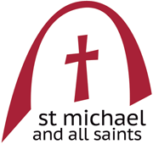**Sunday September 22nd 2024**

**Harvest Festival** 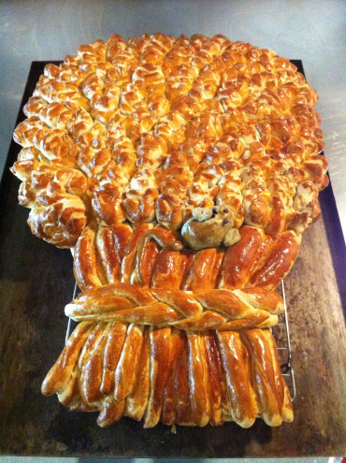

**[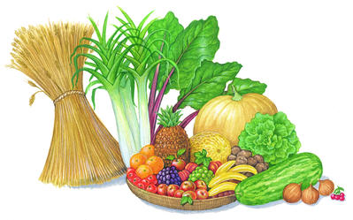](https://www.google.co.uk/url?sa=i&rct=j&q=&esrc=s&source=images&cd=&cad=rja&uact=8&ved=0ahUKEwjT8PqF1a3PAhVDuxQKHUbkC_cQjRwIBw&url=https://gridclub.com/subscribers/info/fact_gadget_2009/festivals/festivals/seasonal_festivals/3131.html&bvm=bv.133700528,d.ZGg&psig=AFQjCNH0rqix5rRWSBIeGfmgoxXV9H56pQ&ust=1475000941033857)**

***Welcome to this church and this service***

*The main part of the service is found in the green Mass in Ordinary Time booklet. This pew-sheet gives details of the parts of the service that change week by week.*

**Everyone** is welcome to come forward at the giving of Communion, either to receive the Sacrament or a personal blessing.

Gluten-free wafers and non-alcoholic wine are available on request. Please let the sidesperson know***.***

**Mass setting:**

*A Short Communion Service* **- Adrian Batten (1591-1637)**

**Organ Music:**

***Andante in G***

Samuel Sebastian Wesley

(1810-76)

**Welcome and notices**

**Introit Hymn:**

**259 Come ye thankful people**

**Introit** *(p3*): Hear, O Lord, and have mercy upon me: Lord be thou my helper. *Ps*. I will magnify thee, O Lord, for thou has set me up and not made my foes to triumph over me. Glory be …

**Gloria** *(p 4):* setting by Shaw

**Collect** *(p 8):* O Almighty and Everlasting God, who hast given unto us the fruits of the earth in their season, and hast crowned the year with thy goodness: Give us grateful hearts, that we may unfeignedly thank thee for all thy loving-kindness, and worthily magnify thy holy Name; through Jesus Christ our Lord who liveth and reigneth with thee and the Holy Spirit, ever one God, world without end. **Amen.**

**Old Testament Reading:** Deuteronomy 8.7-18

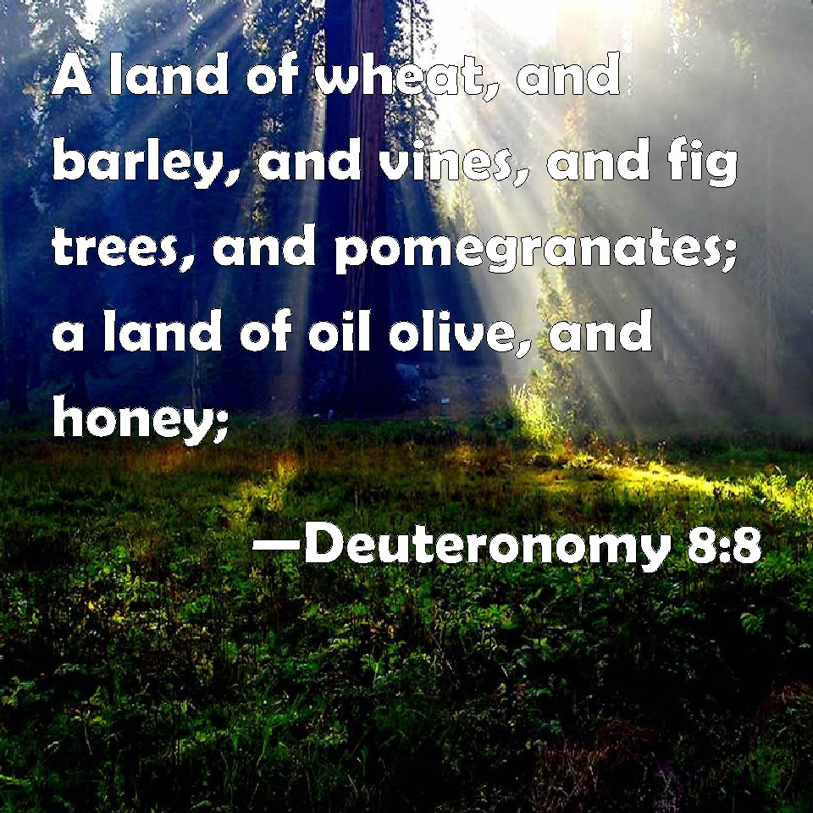For the Lord your God is bringing you into a good land, a land with flowing streams, with springs and underground waters welling up in valleys and hills, a land of wheat and barley, of vines and fig trees and pomegranates, a land of olive trees and honey, a land where you may eat bread without scarcity, where you will lack nothing, a land whose stones are iron and from whose hills you may mine copper. You shall eat your fill and bless the Lord your God for the good land that he has given you.

Take care that you do not forget the Lord your God, by failing to keep his commandments, his ordinances, and his statutes, which I am commanding you today. When you have eaten your fill and have built fine houses and live in them, and when your herds and flocks have multiplied, and your silver and gold is multiplied, and all that you have is multiplied, then do not exalt yourself, forgetting the Lord your God, who brought you out of the land of Egypt, out of the house of slavery, who led you through the great and terrible wilderness, an arid waste-land with poisonous snakes and scorpions. He made water flow for you from flint rock and fed you in the wilderness with manna that your ancestors did not know, to humble you and to test you, and in the end to do you good. Do not say to yourself, ‘My power and the might of my own hand have gained me this wealth.’ But remember the Lord your God, for it is he who gives you power to get wealth, so that he may confirm his covenant that he swore to your ancestors, as he is doing today.

**Epistle**: 1 Timothy 2.1-7

First of all, then, I urge that supplications, prayers, intercessions, and thanksgivings should be made for everyone, for kings and all who are in high positions, so that we may lead a quiet and peaceable life in all godliness and dignity. This is right and is acceptable in the sight of God our Saviour, who desires everyone to be saved and to come to the knowledge of the truth. For there is one God; there is also one mediator between God and humankind, Christ Jesus, himself human, who gave himself a ransom for all —this was attested at the right time. For this I was appointed a herald and an apostle (I am telling the truth, I am not lying), a teacher of the Gentiles in faith and truth.

**Gradual & Alleluia:** I was glad when they said unto me: we will go into the house of the Lord. Peace be within thy walls: and plenteousness within thy palaces.

(Cantor) Alleluia, alleluia, alleluia.

**(All) Alleluia, alleluia, alleluia.**

**Sing we merrily unto God our strength; make a cheerful noise unto the / God of / Jacob:**

**Take the psalm, bring / hither. the / tabret.**

**Alleluia, alleluia, alleluia.**

**Gospel:** Matthew 6.25-33

Therefore I tell you, do not worry about your life, what you will eat or what you will drink, or about your body, what you will wear. Is not life more than food, and the body more than clothing? Look at the birds of the air; they neither sow nor reap nor gather into barns, and yet your heavenly Father feeds them. Are you not of more value than they? And can any of you by worrying add a single hour to your span of life? And why do you worry about clothing? Consider the lilies of the field, how they grow; they neither toil nor spin, yet I tell you, even Solomon in all his glory was not clothed like one of these. But if God so clothes the grass of the field, which is alive today and tomorrow is thrown into the oven, will he not much more clothe you—you of little faith? Therefore do not worry, saying, “What will we eat?” or “What will we drink?” or “What will we wear?” For it is the Gentiles who strive for all these things; and indeed your heavenly Father knows that you need all these things. But strive first for the kingdom of God and his righteousness, and all these things will be given to you as well.

**Sermon**: preacher Fr Oliver Brewer Lennon

**Intercessions** *(p 14):*

**Sick, housebound and those in need**: Andy Bayliss, Martin Boland, Philip Bradfield, Peter Dickins, Christine Dunbar, Betty Duncan, Mary Findlay, David Glews, Morag Graham Brown, Sarah Gundry, Di McAdam, Euan Morley, Suzanna Ovenstone, Angelica Paterson, Isobel Poole, Jean Simpson and Susan Virtue.

**Year’s mind**: Dorothy Cotton, George Tonge, Cornelius Bawden, Oliver Matthews, Mary Charles, Sister Benedicta of All Saints, James Fraser, Maud Warner, Ian Wills, John Paul (Pr), Richard Collier, Dorothea Beattie, Robert Borthwick, Alfred Fischer, Kenneth Mackenzie, Sandy Anderson.

***Please stand for* The Peace**(*p.15*)

***The Peace*** *may be exchanged in the traditional way, but please be sensitive towards those who do not wish to do so.*

**The Offertory:** *If you wish to make a cash donation, please place it in an envelope (to be found in the front of the hymn book) and it will be collected during the hymn.*

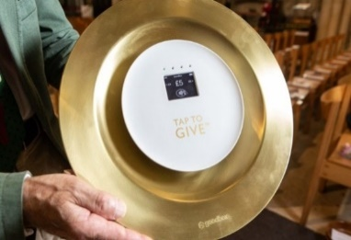 *Contactless donations may be made by using our giving plate at the back of the church. Standing order is the preferred method of regular giving.*

*Please consider Gift Aid for your donations.*

**Offertory:** My hope hath been in thee, O Lord: I have said, Thou art my God, my time is in thy hand.

***Fr Oliver has begun to say the***[***Secret***](https://www.catholic.com/encyclopedia/secret)***(Lat. Secreta, sc. oratio secreta). The prayer is said in a low voice by the celebrant at the end of the***[***Offertory***](https://www.catholic.com/encyclopedia/offertory)***. It is the original and, for a long time, was the only offertory prayer. It is said in a low voice merely because at the same time the choir sings the***[***Offertory***](https://www.catholic.com/encyclopedia/offertory)***, and it has inherited the special name of***[***Secret***](https://www.catholic.com/encyclopedia/secret)***as being the only prayer said in that way.***

**The Secret:** O Lord Jesus Christ, who hast taught us that man doth not live by bread alone: Feed us, we humbly beseech thee, with the true Bread that cometh down from heaven, even thyself, O blessed Saviour; who liveth and reigneth with the Father and the Holy Spirit, one God, world without end. Amen.

**Offertory hymns: 397 Let us with a gladsome mind**

**262 We plough the fields**

**The Prayer of Consecration** *(p 18)* *including the preface*

Because the wonders of thy Creation reflect thy goodness and beauty, and thy gifts of sun and rain, seed-time and harvest manifest thy continual care and love for all that thou hast made.

**The Invitation and Communion** *(p. 26)*

**Communion sentence:** The earth, O Lord, is filled with the fruit of thy works: that thou mayest bring food out of the

earth, and wine that maketh glad the heart of man. And oil to make him a cheerful countenance: and bread to strengthen man’s heart.

**Everyone** is welcome to come forward at the giving of Communion, either to receive the Sacrament or a personal blessing.

**The Distribution**

**Communion anthem:** *Pleasure it is* - Nicholas O'Neill (b.1970)

Pleasure it is to hear iwis, the Birdes sing,

the deer in the dale,

the sheep in the vale

the corn springing.

God's purveyance for sustenance,

It is for man.

Then we always to give him

and thank him than.

William Cornysh (1465-1523)

**Communion hymn: 264 All things bright and beautiful**

**Post-communion collect** *(p 28):* God of our hope, in this sacrament we have found the source of all thy blessings: so nourished by these holy mysteries, may we with our lives give unto thee continual thanks and praise, through Jesus Christ our Lord,who liveth and reigneth with thee, in the unity of the Holy Spirit, ever one God, world without end.

**Amen.**

**Blessing:** The God of all grace, who called you to his eternal glory in Christ Jesus, establish, strengthen and settle you in the faith; and the blessing of God almighty, the Father, the Son, and the Holy Spirit, be among you and remain with you always. **Amen.**

***Maggie’s House talk by Gillian Harrison, a member of the fund-raising team at Maggie’s Cancer Centre, Edinburgh.***

*****Maggie's****centres are a network of drop-in centres across the United Kingdom and abroad that aim to help anyone who has been affected by cancer.*

*They are intended as welcoming and caring environments that provide support, information and practical advice to people dealing with a cancer diagnosis. They also offer wellbeing sessions and workshops to complement conventional cancer therapy*

**Angelus** (*p 30)*

**Recessional hymn:**  **285 For the beauty of the earth**

**Organ Music:** *Festal March* - Sir George Elvey (1816-93)

***Please join us after the service for refreshments at the back of the church***

**Notices for week beginning September 22nd**

Church Keys

It has been decided that the yale lock of the church door is to be changed. The new key will be issued to those whose name is on the key register, which is held currently by Sheena Liddell. If you are a key holder, you need to check your name is on her list.

D**oors Open Day** is the weekend of **28th and 29th September**. We will be open on Saturday 28th Sept from 11:00am to 4:00pm **AND** on Sunday from noon to 4:00pm.

We will need volunteers to welcome visitors and steward this event which has been very popular in the last few years with more than 150 people coming through our open doors. People are being asked to do 2-hour slots. The rota is on the noticeboard. Please sign up and help us have the church open.

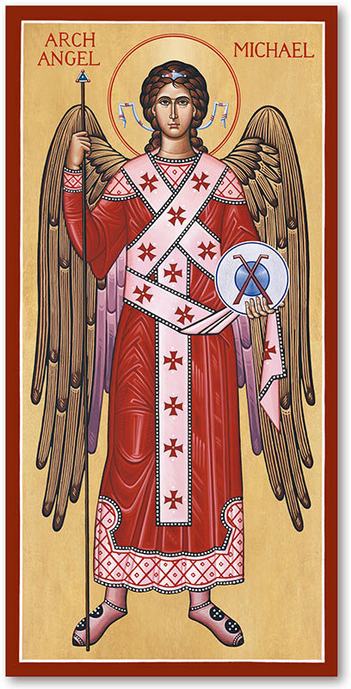

**Sunday September 29th**

**Feast of St Michael and All Angels**

There will be a High Mass for our first patronal festival at 10.30. **We** will be serving Fizz and Soft Drinks, and Nibbles, after the service.

Our prayers are asked for those who are to be ordained to the diaconate on Sept 29th at St Mary’s Cathedral - Eilidh Proudfoot, Fiona Reynolds and Simon Scholfield.

+ John writes to us saying: -

*Dear Friends*

*On Sunday 29th September, Michaelmas, at 3.30pm, there will be an Ordination Service at the Cathedral. Three people will be ordained Deacon. This is a Diocesan event, and it would be lovely to see our ordinands supported by clergy and people from across the diocese.*

*If you can, please do make an effort to be with us on 29th. I’m sure those clergy and congregations who have accompanied our ordinands during their discernment and those who will receive their ministry will want to be present, but I would encourage others, who may not know them, to attend as well so that Eilidh, Fiona and Simon may feel surrounded by the prayer of the whole diocese.*

*Every blessing*

*+John*

**The Social Committee are planning some entertaining events for Autumn, please put the dates in your diaries!**

**Friday 4 October 7.00 – 9.00 – in the Narthex**.

**A** Quiz Evening, including a section on our new Rector – how much do you know about him?! Wine, soft drinks and nibbles provided!

**Friday 1 November** **7.00 – 9.00 – in Church**

‘Saints and Sinners Showcase’ – come and share your creative talents – poetry, music, art work – we would like to hear you!

**Saturday 30 November** **11.00 – 1.30 – in Church**

SMAS Grand Christmas Fayre! In aid of our two charities – Maggie’s Cancer Care and Medicine Sans Frontiers Gifts, Cards, Cakes & Baked Goods, Bric a Brac, Raffle, Refreshments

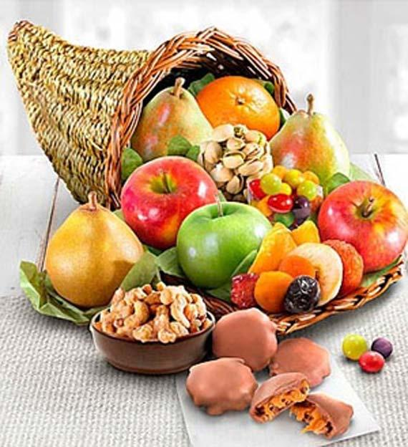

What's on in church this week

Rector: Fr Oliver Brewer Lennon

Email*:* [**rector@stmichaelandallsaints.org**](mailto:rector@stmichaelandallsaints.org)

Phone: [07954 314 374](tel:+44+(0)+7954+314+374)

Scottish Charity no. SC016184

|  |  |  |
| --- | --- | --- |
| **Sunday22nd**  **September**  **HARVEST FESTIVAL** | **10.30am** | **High Mass** |
| **Monday 23rd**  Adamnan of Iona, Abbot, 704 |  |  |
| **Tuesday 24th** |  |  |
| **Wednesday 25th**  Finnbar of Caithness, Bishop,  c 610 | 11.00am | **Low Mass** *followed by a light lunch* |
| **Thursday 26th** |  |  |
| **Friday 27th**  Vincent de Paul, Priest, 1660 |  |  |
| **Saturday 28th** |  |  |
| **Sunday 29th**  **September**  **St Michael and All Angels** | **10.30am** | **High Mass** |