

**Sunday August 4th 2024**

**The Transfiguration of our Lord**

***Welcome to our church***

***and to this service***

This pew-sheet gives details of the parts of the service that change week by week; it should be used with the Mass in Ordinary Time book

(page number shown in brackets).

***Everyone*** *is welcome to come forward at the giving of Communion, either to receive the Sacrament or a personal blessing.*

Gluten-free wafers and non-alcoholic wine are available on request. Please let the sidesperson know***.***

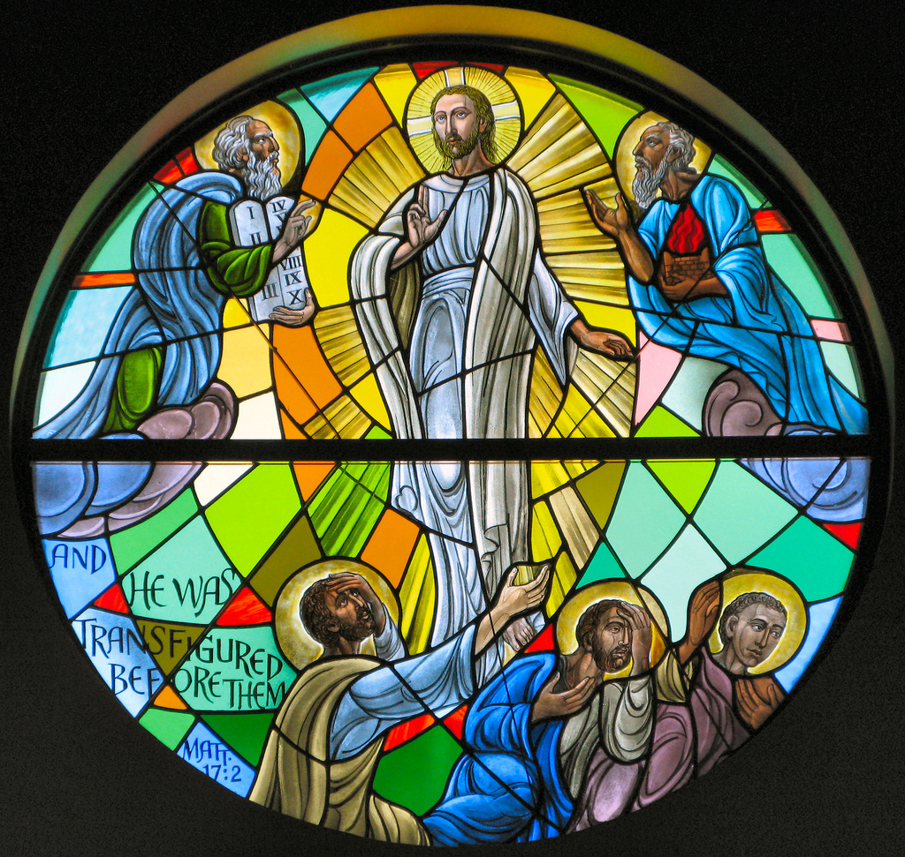

**Organ music**: Christe, der du bist Tag und Licht - Johann Sebastian Bach

**Mass setting**: *Communion Service in G* – Francis Jackson

**Welcome and notices**

Celebrant: Let us proceed in peace

**All: In the name of Christ. Amen.**

**Processional hymn: 338 At the name of Jesus (omit *)**

**Introit** *(p3*): My heart hath talked of thee. I have sought thy face, thy face Lord, will I seek; O hide not thou thy face from me. *Ps.* The Lord is my light and my salvation: whom then shall I fear? Glory be……

**The Kyries** *(p3):*

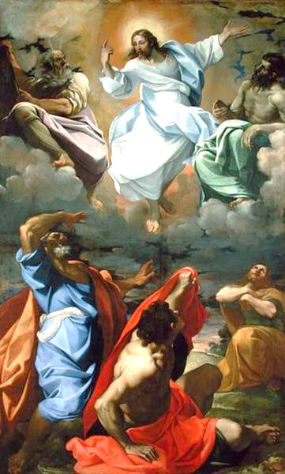

**Gloria** *(p5): setting by Jeffcoat*

**Collect** *(p8****):*** Almighty God, on the holy mount thou didst reveal to chosen witnesses thy well-beloved Son, wonderfully transfigured: mercifully deliver us from the darkness of this world, and change us into his likeness from glory to glory; through Jesus Christ our Lord, who liveth and reigneth with thee and the Holy Spirit, one God, now and for ever.  **Amen.**

**Old Testament Reading:**  Daniel 7: 9-10; 13-14

As I watched,  
thrones were set in place,  
   and an Ancient One took his throne;  
his clothing was white as snow,   
   and the hair of his head like pure wool;  
his throne was fiery flames,  
   and its wheels were burning fire.   
A stream of fire issued  
   and flowed out from his presence.  
A thousand thousand served him,  
   and ten thousand times ten thousand stood attending him.  
The court sat in judgement,  
   and the books were opened.

As I watched in the night visions,  
I saw one like a human being  
   coming with the clouds of heaven.  
And he came to the Ancient One  
   and was presented before him.  
To him was given dominion  
   and glory and kingship,  
that all peoples, nations, and languages  
   should serve him.  
His dominion is an everlasting dominion  
   that shall not pass away,  
and his kingship is one  
   that shall never be destroyed.

**Epistle**: 2 Peter 1: 16-19

For we did not follow cleverly devised myths when we made known to you the power and coming of our Lord Jesus Christ, but we had been eyewitnesses of his majesty. For he received honour and glory from God the Father when that voice was conveyed to him by the 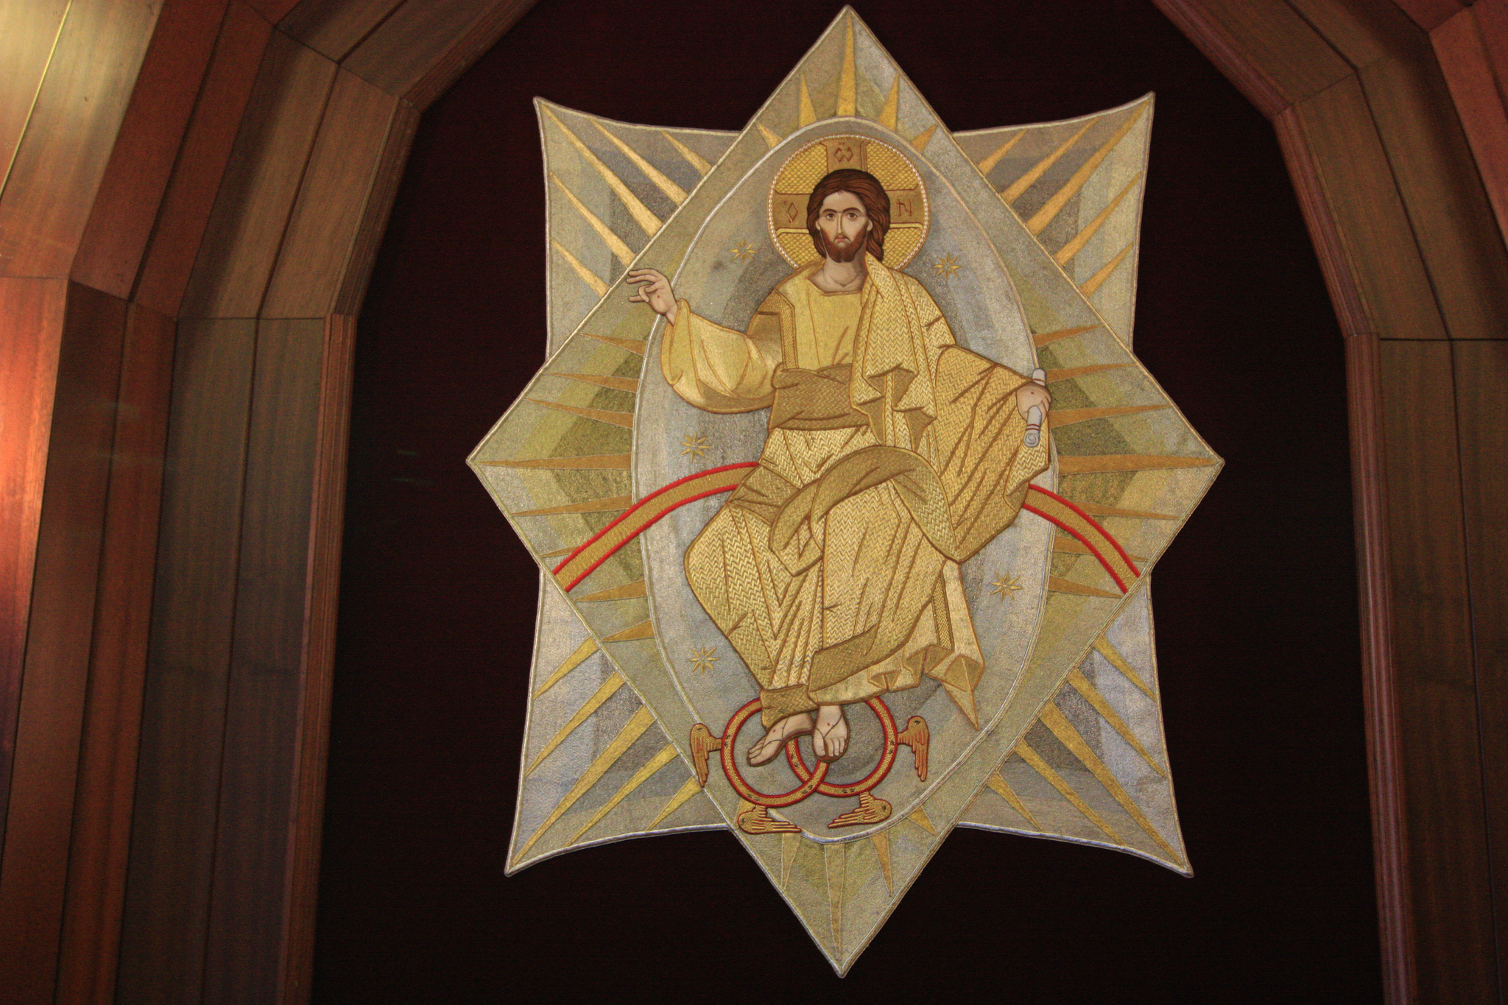Majestic Glory, saying, ‘This is my Son, my Beloved, with whom I am well pleased.’ We ourselves heard this voice come from heaven, while we were with him on the holy mountain.

So we have the prophetic message more fully confirmed. You will do well to be attentive to this as to a lamp shining in a dark place, until the day dawns and the morning star rises in your hearts.

**Gradual & Acclamation:**  Thou art fairer than the children of men: Full of grace are thy lips. My heart is indicting of a good matter: I speak of the things which I have made unto the King: my tongue is the pen of a ready writer.

Rejoice in the Lord, ye righteous: and give thanks for a remembrance of his holiness.

(Cantor) Alleluia, alleluia, alleluia.

**(All) Alleluia, alleluia, alleluia.**

**He is the brightness of the ever/-lasting/ light,**

**the unspotted mirror of the power of God, and the image / of his / goodness.**

**Alleluia, alleluia, alleluia.**

**Gospel:** Luke 9: 28-36

Now about eight days after these sayings Jesus took with him Peter and John and James and went up on the mountain to pray. And while he was praying, the appearance of his face changed, and his clothes became dazzling white. Suddenly they saw two men, Moses and Elijah, talking to him. They appeared in glory and were speaking of his departure, which he was about to accomplish at Jerusalem. Now Peter and his companions were weighed down with sleep; but since they had stayed awake, they saw his glory and the two men who stood with him. A group of men standing on a rock
Just as they were leaving him, Peter said to Jesus, ‘Master, it is good for us to be here; let us make three dwellings, one for you, one for Moses, and one for Elijah’—not knowing what he said. While he was saying this, a cloud came and overshadowed them; and they were terrified as they entered the cloud. Then from the cloud came a voice that said, ‘This is my Son, my Chosen; listen to him!’ When the voice had spoken, Jesus was found alone. And they kept silent and, in those days, told no one any of the things they had seen.

**Sermon**: preacher – Fr Bill Robertson

**Intercessions** (*p14*):

**Sick, housebound and those in need**: Andy Bayliss, Martin Boland, Philip Bradfield, Peter Dickins, Christine Dunbar, Betty Duncan, Mary Findlay, David Glews, Morag Graham Brown, Sarah Gundry, Di McAdam, Euan Morley, Suzanna Ovenstone, Angelica Paterson, Christine Percival, Isobel Poole, Michele Russell, Jean Simpson and Susan Virtue.

**Year’s mind:** Lucy Catherine Reid, Richard Allan, Thomas Anderson**,** James Ferguson, the victims of the Hiroshima bomb,Thomas Scott Pow, Robert Norcliffe, William Jones, Henry Edward Reid (Pr), Beatrice Blackwood, George Kerr, Andrew McAdam, Duncan Macinnes, Margaret Brown Charles, the victims of the Nagasaki bomb, Janet Wallace and Agnes Whyte.

***Please stand for The* Peace**(*p.15*)

***The Peace*** *may be exchanged in the traditional way, but please be sensitive towards those who do not wish to do so.*

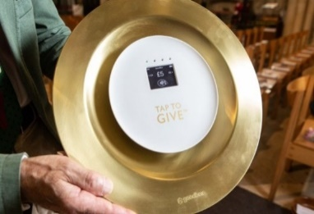**The Offertory:** *If you wish to make a cash donation, please place it in an envelope (to be found in the front of the hymn book) and it will be collected during the hymn. Contactless donations may be made by using our giving plate at the back of the church. Standing order is the preferred method of regular giving.*

*Please consider Gift Aid for your donations.*

**Offertory**: Thou hast crowned him with glory and worship: and hast made him to have dominion of the works of thy hands, O Lord.

**Offertory hymns: 178 'Tis good Lord to be here**

**332 All hail the power**

**The Prayer of Consecration** *(p.17)* ***including the Preface***

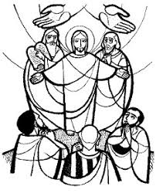

**Proper Preface:**  Because thou hast made known to us the honour and glory of thy beloved Son, to whom before his passion thy voice bare witness on the holy Mount. Therefore with Angels…

**The Invitation and Communion** *(p.26)*

**Communion Sentence:** Tell the vision to no man; until the Son of Man be risen again from the dead.

**The Distribution**

**Everyone** is welcome to come forward at the giving of Communion, either to receive the Sacrament or a personal blessing.

**Communion anthem:** *Let all the world in ev’ry corner sing* – Ralph Vaughan Williams (1872-1958)

Let all the world in every corner sing,  
‘My God and King!’  
The heavens are not too high,  
his praise may thither fly;  
the earth is not too low,  
his praises there may grow:  
let all the world in every corner sing,  
‘My God and King!’

Let all the world in every corner sing,  
‘My God and King!’  
The church with psalms must shout   
no door can keep them out;  
but above all, the heart  
must bear the longest part:  
let all the world in every corner sing,  
‘My God and King!’

**[George Herbert (1593-1633)]**

**Communion hymn:** **410 My God how wonderful thou art**

**Post-communion collect** (*p.27*)**:** Holy God, as we see thy glory in the face of Jesus Christ, so may we who are partakers of his table reflect his life in word and deed, that all the world may know his power to change and save; through the same Jesus Christ our Lord. **Amen.**

**The Blessing**:Christ our king make you faithful and strong to do his will, that you may reign with him in glory; and the blessing of God almighty, the Father, the Son, and the Holy Spirit, be among you and remain with you always,

**All:**  **Amen.**

**Angelus** (*p.28*)

**Recessional hymn: 286 From glory to glory**

**Organ Music:** *Christ ist erstanden* - Johann Sebastian Bach

***Please join us after the service for refreshments at the back of the church***

**Notices for week beginning August 4th 2024**

**Opening the Church during the Festival**

Edinburgh’s Arts Festival is now open and it would be wonderful if we can gather enough stewards to open the church to visitors during the day. Would you help out

A list of dates and times is on the Notice Board in the Narthex. Please sign up, if only for one session!

Please ask Faith if you have any questions.

The recipients of the first Michael Jessing bursary are exhibiting their work in the church on August 16th. Please make time to come and see it.

Watch out for some of Michael’s work being shown in the Lady Chapel soon.

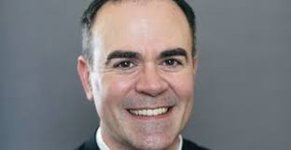Fr Oliver’s institution will be:

**Wednesday 4 September 2024 at 7.00pm here in St Michael and All Saints Church**

St Salvador’s Community Food Initiative

This month Carolyn took over 70 items to St Salvador’s. This was double the amount taken the month before. Well Done everyone. Can we keep this up? St Salvador’s helps 100 families each week.

Please keep everyone informed of what’s going on in church and among our members. Please send items for inclusion on the **next Sunday’s pew sheets** (names of the sick, notices etc) to Helen Daniell by Thursday evening. 0131 660 6056; helen@helendaniell.co.uk

Please check **the availability of the church** before planning

activities. Sam Campbell, the parish administrator, should be **notified of all activities taking place in the church and all bookings** should be made through her:

[admin@stmichaelandallsaints.org](mailto:admin@stmichaelandallsaints.org)

**Interim Pastor: Fr Paul Burrows**

*Email:***rector@stmichaelandallsaints.org**

|  |  |  |
| --- | --- | --- |
| **Sunday August 4th**  **Feast of the Transfiguration of our Lord**  **(transferred)** | 9.00am  10.30am | Choir Practice  **High Mass (r)** |
| **Monday 5th**  Oswald of Northumbria, Martyr, 642 |  |  |
| **Tuesday 6th** |  |  |
| **Wednesday 7th**  John Mason Neale, Priest, 1866 | 11.00pm | **Low Mass** *followed by a light lunch* |
| **Thursday 8th**  Dominic, Priest and Friar, 1221 |  |  |
| **Friday 9th** |  |  |
| **Saturday 10th**  Lawrence, Deacon and Martyr, 258 |  |  |
| **Sunday August 11th**  **19th Sunday in Ordinary Time** | 9.00am  10.30am | Choir Practice  **High Mass (r)** |

